CSS

Contents

1. Introduction to CSS 2

CSS Selector 3

CSS Color 4

CSS Font 5

2. CSS Box Model 7

The <div> element 8

CSS Cascade 8

1. Positing 9

2. Specificity 9

3. Type 10

4. Important 10

# Introduction to CSS

* CSS (Cascading Style Sheets) is a programming language used to style HTML elements. It controls the appearance of web pages, including colors, fonts, layouts, and more. By separating the content (HTML) from the presentation (CSS), CSS makes it easier to create visually appealing and maintainable websites.
* Key benefits of using CSS:
  + **Separation of concern**s: Keeps the HTML code focused on content and the CSS focused on presentation.
  + **Reusability**: Styles can be defined once and applied to multiple elements.
  + **Maintainability**: Changes to the design can be made easily without modifying the HTML.
  + **Cross-browser compatibility**: CSS ensures consistent styling across different browsers.
* **Basic CSS** Syntax**:**
  + **Selectors:** Specify which elements to style.
  + **Properties:** Define the desired style attributes.
  + A screen shot of a computer

    Description automatically generated**Values:** Assign values to the properties.
* There are three primary ways to add CSS to an HTML document:

1. Inline CSS:

* Directly within the HTML element using the style attribute.
* Best for applying styles to a single element.

1. Internal CSS:

* Within the <head> section of the HTML document using a <style> tag.
* Suitable for styling multiple elements within the same document.

1. External CSS:

* In a separate CSS file linked to the HTML document using the <link> tag.
* A graph showing different colored arrows

  Description automatically generated with medium confidenceBest for managing styles for multiple HTML pages and separating content from presentation.

## CSS Selector

* CSS selectors are used to target specific elements or groups of elements within an HTML document. Here's a breakdown of the four main types of selectors:

1. **Element Selector**: Selects HTML elements based on their tag name.

* 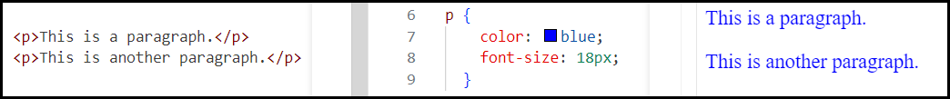Example: p will select all <p> elements.

1. **Class Selector**: Selects elements that have a specific class attribute.

* 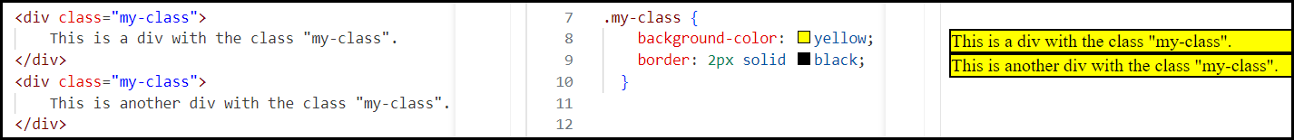Example: .my-class will select all elements with class="my-class".

1. **Attribute Selector**: Selects elements based on the presence or value of their attributes.

* A screenshot of a computer

  Description automatically generatedExample: a[href] will select all elements with an href attribute.

1. **ID Selector**: Selects a specific element based on its unique ID.

* Example: #my-heading will select the element with id="my-heading".

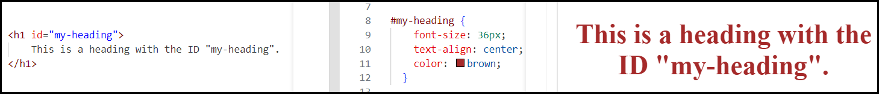

1. **Universal Selector**: Selects all elements on the page.

* Example: * will select all elements, regardless of their type.

## CSS Color

* **CSS** provides various ways to specify colors for elements, including:
  + **Named Colors**
    - 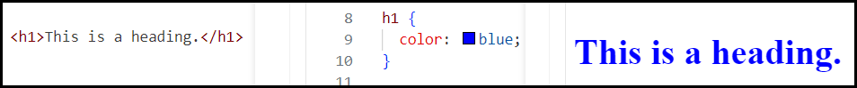Predefined color names like red, blue, green, yellow, black, white, etc.
  + **Hexadecimal Color Codes**
    - A six-digit code representing the amounts of red, green, and blue (RGB) in the color.
    - 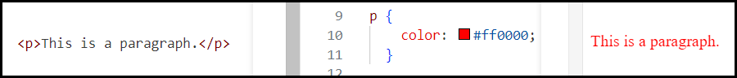Each pair of digits represents the intensity of a color channel (00-FF).
  + **RGB Color Values**
    - Specifies the color using the amounts of red, green, and blue (RGB).
    - 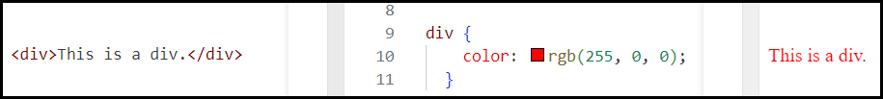Values can be specified as percentages (0-100%) or integers (0-255).
  + **RGBA Color Values**
    - Similar to RGB, but also includes an alpha channel for transparency.
    - The alpha channel value ranges from 0 (fully transparent) to 1 (fully opaque).



Note: <https://colorhunt.co/> -> Color palettes.

## CSS Font

* A screen shot of a computer code

  Description automatically generatedCSS provides various properties to control the appearance of text on a web page. Here are some of the most commonly used font properties:
  + font-family
    - font-family property in CSS is used to specify the typeface for text.
    - Can be a single font name or a **comma-separated list** of fonts.

#### Question: what is typeface?

* A typeface is a collection of characters (letters, numbers, symbols) that share a common design. It is the overall design or style of the text.
* Think of a typeface as the visual style or look of the text.

#### Question: what is font?

* A font is a specific style, weight, and size within a typeface. It refers to the individual files that you use on your computer to create the text.
  + For example, Arial **Bold** 12pt is a font, whereas Arial is the typeface.
* A typeface can have multiple fonts, such as Arial Regular, *Arial Italic*, **Arial Bold**, and ***Arial Bold Italic.***
* You can think of a typeface as a family name (like "Arial") and a font as a specific family member (like "Arial Bold 12pt").
  + font-size
    - Sets the size of the font.
    - Can be specified in pixels (px), ems, rems, percentages, or other units.

#### Question: what is pixel?

* A **pixel** (short for "picture element") is the smallest unit of a digital image. It represents a single point in a grid of colors that make up the image.
* Think of a pixel as a tiny dot on a screen. When you zoom in on an image, you can see the individual pixels that form the picture. The higher the resolution of an image, the more pixels it contains, resulting in a sharper and more detailed picture.

$$1 CSS pixel=\frac{1}{96} inch$$

$$1 pt=\frac{1}{72} inch$$

$$1 em=100\% of Parent$$

$$1 rem=100\% of Root$$

Note: <https://fonts.google.com/> -> Free fonts

# CSS Box Model

* The CSS box model is a conceptual model that represents how elements are rendered on a web page.
* Each element is a box in itself.
* It consists of four main components:

1. **Content:** The actual content of the element, such as text, images, or other elements.
2. **Padding:** The space between the content and the border.
3. **Border:** The outline or edge of the element.
4. **Margin:** The space outside the border, between the element and its neighbouring elements.

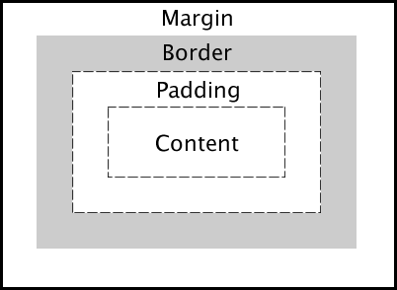

## The <div> element

* The **div** element (as shown in the above picture) in HTML is a block-level container used to group and organize other HTML elements.
* It stands for "division" and is often used to create sections or divisions within a web page.

#### Question: When to Use a div Element:

* **Layout and Grouping**: To group related elements and create page layouts.
* **Styling**: To apply styles to a group of elements using CSS.
* **JavaScript Manipulation**: To easily manipulate groups of elements with JavaScript.

## CSS Cascade

* What exactly is the meaning of the cascading part of the cascading style sheet?
* It is relevant when we think about multiple different conflicting CSS rules.
* A white background with red text

  Description automatically generatedLet's say we've got an ordered list which has three list items, and then in our styles.css we set all of the list items to have a green color.
* A close-up of a graph

  Description automatically generatedIf one of those list items happened to have an inline style where we've got the style attribute being set and we set it to a different color in this case, red. Now that element will turn Red.
* There are four broad categories while determining the importance of a CSS rule. They are…
  1. Position
  2. Specificity
  3. Type
  4. Importance

### Positing

* Checks if a rule is at a higher or lower position in the CSS relative to other rules.
* In the below example, two rules are being applied to the same thing and setting the same property. The one that is lower down simply replaces the previous one.
* So, the lower down the file, the rule is, the more important, it is.

### Specificity

* CSS specificity refers to how specific a selector is in terms of the elements that you're applying the CSS rule to.
* For example, let's say we create a <p> (paragraph) item element and give an id id="first-id" and then we give it a class class="first-class" then finally we give it the attribute of "draggable" as well.
* We think about the different ways that we can target this element, then these four CSS rules will all target this particular element.

* These 4 CSS rules have different Specificity and they're listed in order…

1. The first one selects all the <p> elements, so there could be many other <p> elements in our HTML file. So, this is the least specific.
2. The next level of Specificity is the class selector. The class selector starts with a dot (.) and this will select all the other <p> elements that have this class name, "first-class". Because we can have multiple different elements with the same class for this reason it is more specific than element, but it's also not the most specific way of selecting an element.
3. The next one is selecting an attribute. We're selecting on this attribute of "draggable" and we're turning the <p> that has that attribute set to the color of black.
4. The final level of Specificity and the most specific is the ID selector, which is denoted by the pound sign or the hashtag sign (#). This is the most specific because theoretically on a single web page you should only have one particular ID name. So, it essentially targets only one element on the page.

* So, the order of specificity is ID, attribute, class and element.

### Type

* We know that there are three different ways that we can apply CSS to a particular file.
  + External - external stylesheet which is done using the link element, linking to a particular file in our project folder.
  + Internal - which is done through the style element and putting the CSS in between the open and closing brackets of the style element.
  + Inline - the CSS is applied through the style attribute inside the opening tag of an actual HTML element.

The most important are the styles that are applied inline because this targets only one specific element. It doesn't matter if you have ten others <h1>'s.

* The next one is the internal, because the internal stylesheet only exists inside one web page.
* The next one is external stylesheet. the external stylesheet can actually be applied across many different HTML files as long as you all link to the same CSS file.
* The order where the CSS will get applied is…
  + First, it checks if there are any styles relevant from the external stylesheet.
  + Then checks, whether if there are any from the internal stylesheet.
  + Finally, if there are any inline styles.

### Important

* A keyword that we can apply to any CSS rule, is the "important" keyword.
* We could have a color property set and we know how we set it normally by simply adding a value after the property, but if you add a space and then you add this exclamation mark and then the important word (!important), then this is going to ensure that this is going to be the most important rule relative to that element.
* A screen shot of a computer code

  Description automatically generatedFor example:

